Student Apartments

**All Apartments**

GET - /apartments

Content-type: application/json

A GET request have been sent to fetch all apartments.

The request that have been sent status was 200, If we have status 200 that means it was successful and we are going get the result we have asked.

HTTP/1.1 200

Content-Type: application/json;charset=UTF-8

Date: Wed, 26 Sep 2018 15:42:43 GMT

Connection: close

Content-Length: 343

**Result**:

**[{"id":1,"city":"Eindhoven","price":150,"available":true},{"id":2,"city":"Amsterdam","price":200,"available":true},{"id":3,"city":"Amsterdam","price":100,"available":true},{"id":4,"city":"Eindhoven","price":120,"available":true},{"id":5,"city":"Eindhoven","price":400,"available":true},{"id":6,"city":"Rotterdam","price":136,"available":true}]**

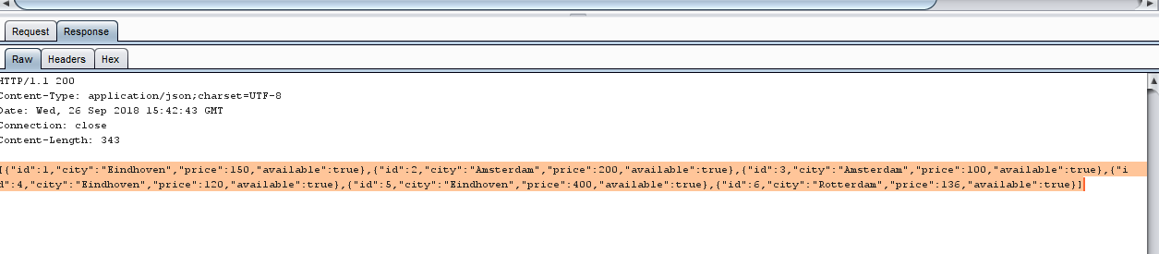

**Fetch All Get Apartment By City**

GET /apartments/search?city=Eindhoven HTTP/1.1

Content-type: application/json

User-Agent: Jakarta Commons-HttpClient/3.1

Host: localhost:8081

A GET request with a parameter **city** where the name of the requested city is passed in the URL, and the server handles it by binding it to the parameter of the endpoint login

HTTP/1.1 200

Content-Type: application/json;charset=UTF-8

Date: Wed, 26 Sep 2018 16:19:02 GMT

Connection: close

Content-Length: 172

**Result**

[{"id":1,"city":"Eindhoven","price":150,"available":true},{"id":4,"city":"Eindhoven","price":120,"available":true},{"id":5,"city":"Eindhoven","price":400,"available":true}]

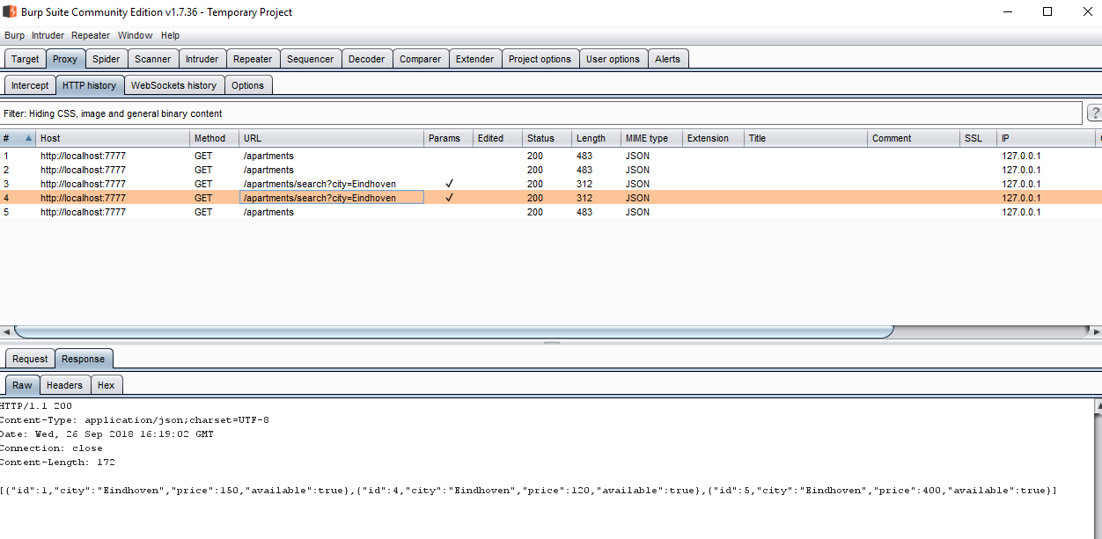

**Get Student**

GET /students HTTP/1.1

Content-type: application/json

A GET request have been sent to fetch get student.

HTTP/1.1 200

Content-Type: application/json;charset=UTF-8

Date: Wed, 26 Sep 2018 17:00:18 GMT

Connection: close

Content-Length: 366

**Result**

successfully get student

[{"id":1,"name":"Mubasher","phoneNumber":"36660237","assignedApartment":0},{"id":2,"name":"Ahmed","phoneNumber":"3666230237","assignedApartment":0},{"id":3,"name":"Ali","phoneNumber":"366560237","assignedApartment":0},{"id":4,"name":"Qasim","phoneNumber":"366660237","assignedApartment":0},{"id":5,"name":"Arbab","phoneNumber":"364678960+237","assignedApartment":0}]

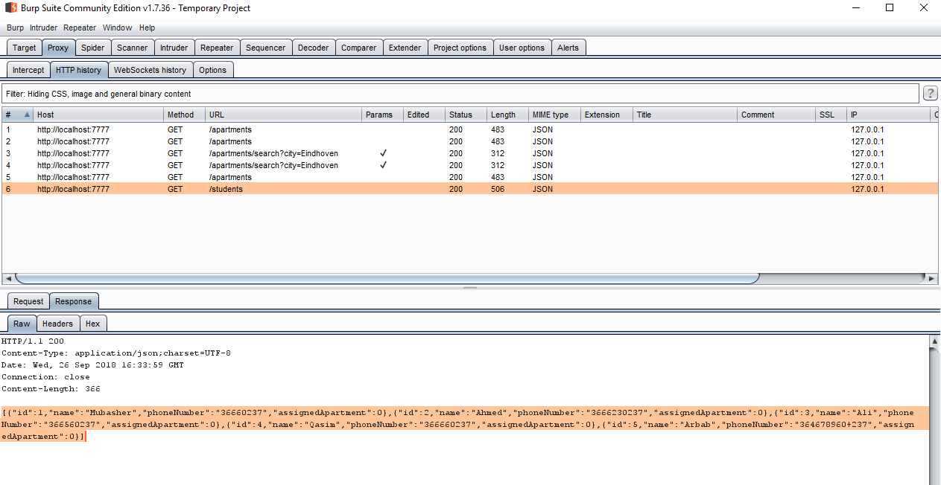

**Create Apartment**

**POST – rooms/create**

A POST method that sends data through the requests body as name and value pairs (JSON). The POST is used to create a new apartment , by taking a apartment id and city as body parameters

{"id":1212,"city":"Budel",

"price":89779797,

"available":false}

A 201-response stating a new instance has been successfully created.

HTTP/1.1 201

Content-Type: application/json;charset=UTF-8

Date: Wed, 26 Sep 2018 17:03:01 GMT

Connection: close

Content-Length: 61

**Result**

Apartment created!

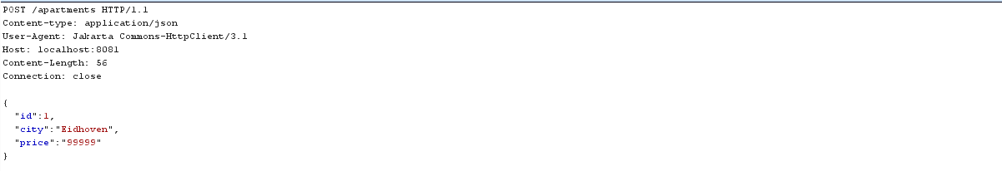

**Delete apartment**

DELETE - /apartment/{apartmentId}/delete

A DELETE request that takes an ID as a parameter. The logic of the endpoints takes that parameter, looks up the room that is requested and deletes it from memory. In this case the request will be sent to **/apartment/1/delete.**

HTTP/1.1 200

Content-Type: text/plain;charset=UTF-8

Content-Length: 18

Date: Wed, 26 Sep 2018 16:49:51 GMT

Connection: close

Apartment deleted!

**Result**

apartment deleted!

